Mrs. Stephanie & Mrs. Freedom’s Newsletter
What’s coming up?
1/15/24 MLK, Jr Holiday
1/16/24 Papa John’s Night
1/18/24 School Council Meeting
2/1/24 & 2/2/24 Prek/K Online Registration

What’s happening in our room?
This week has been about reviewing our rules and routines and just getting back into our groove. Mrs. Freedom’s groups used unifix cubes to make simple patters and then sort them by color.
My group’s practice name writing and some wrote their last names.
January 12, 2024
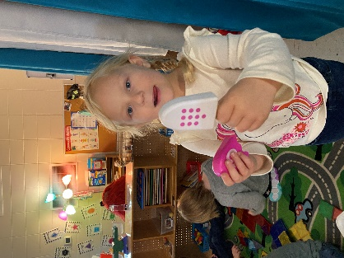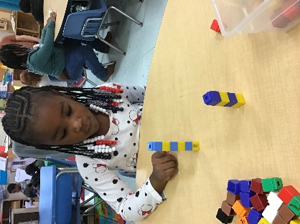
Need me?
sconnally@tcjackets.net , Seesaw or 229-225-3908
Ryn is counting. Zaniyah is making a pattern.

